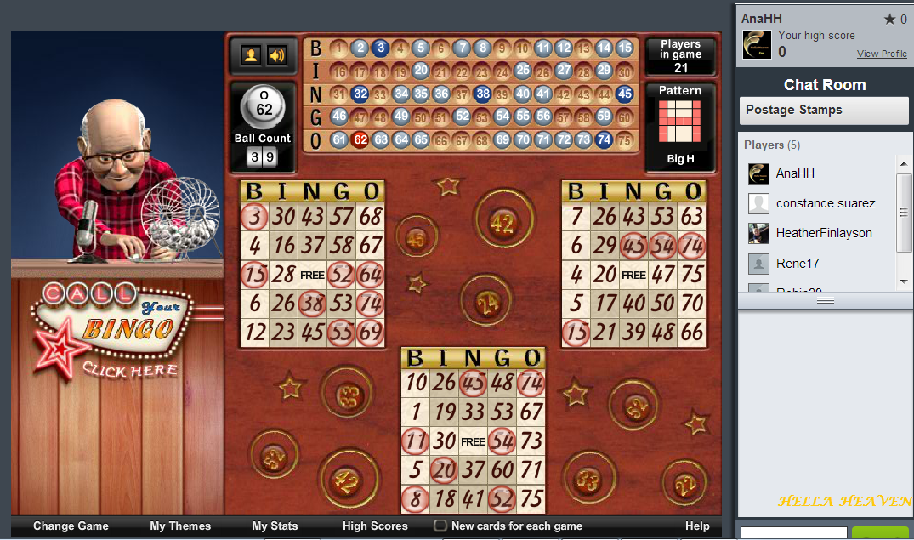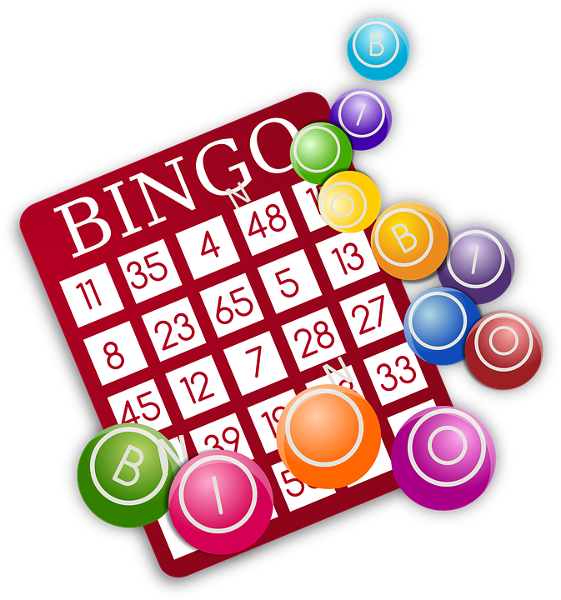

**FALL BIG MONEY BINGO**

NOVEMBER 9, 2024

**$60 person-Includes Dinner, a block of nine game pack,**

**1 game strip for each Special & 1 game strip for Jackpot.**

**14 Games pay up to $600 * Specials pay $500 & $1000 \***

**Jackpot pays $1200** 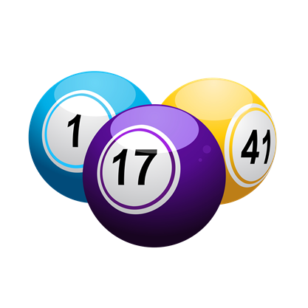

**Doors Open 4 pm * Dinner 4:30pm to 6:00pm * Bingo 6:30pm**

**\*ADDITIONAL Game papers sold 4:30pm**

**(9 pack-$15 / 6 pack-$10 / 3 pack-$5 / Specials & Jackpot $1)**

**Free Coffee & Iced Tea available until last break.**

**Soda & Snacks sold during each of two 15 minute breaks**

**Reservations - LaRue Stevens @ 301-829-2510. Please mail your check**

**SAME DAY, and Include the FIRST & LAST NAME of each player.**

**(Mailing List players can use the enclosed pre-Addressed envelope)**

* **Cut off for paid tickets to be mailed out is Nov. 1st.**
* **NOV 1st – NOV. 6th - Call in Reservations continue as long as tickets are still available. These tickets must be paid for and picked up (at the Libertytown Fire Dept. Social Hall) on either Thur. Nov. 7th or Friday Nov. 8thbetween 4:00 pm and 5:30 pm.**

**Early Reservations strongly suggested for assigned seats & food orders.**

**All checks will be deposited prior to event 11/9**

**\*\* Tickets will be sold *at the door* (if still available) for the Cost of $65.00 \*\***

**CHECKS PAYABLE TO & ALL PROCEEDS BENEFIT THE LIBERTYTOWN FIRE DEPT.**

**LVFD RESERVES THE RIGHT TO REDUCE PAYOUTS IF LESS THAN 150 PLAYERS. NO REFUNDS.**